1. **Install Docker & Running. Need to Create ID & Container**

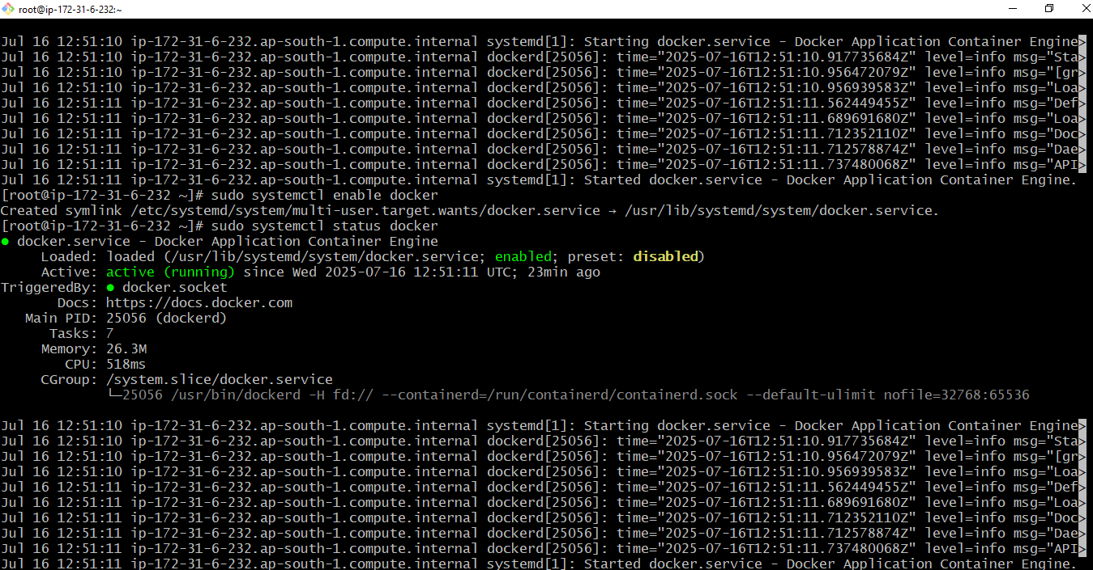

1. Install Jenkins & Running on port 8080.

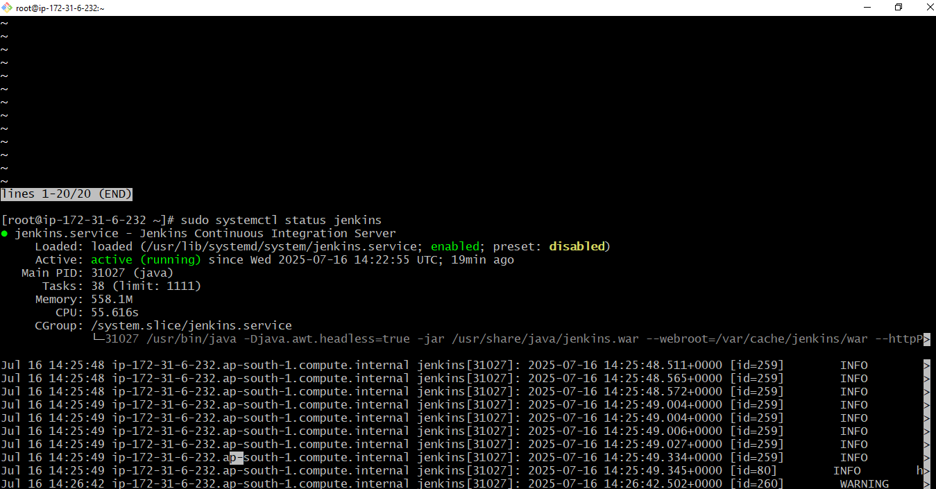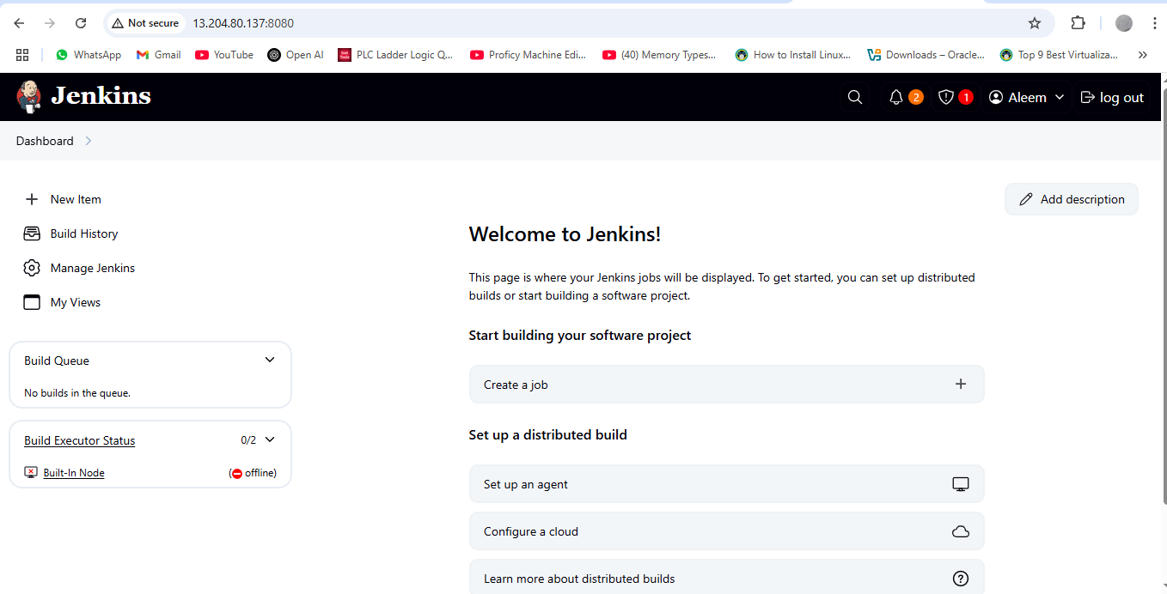

1. Install apache & Running on port 81.

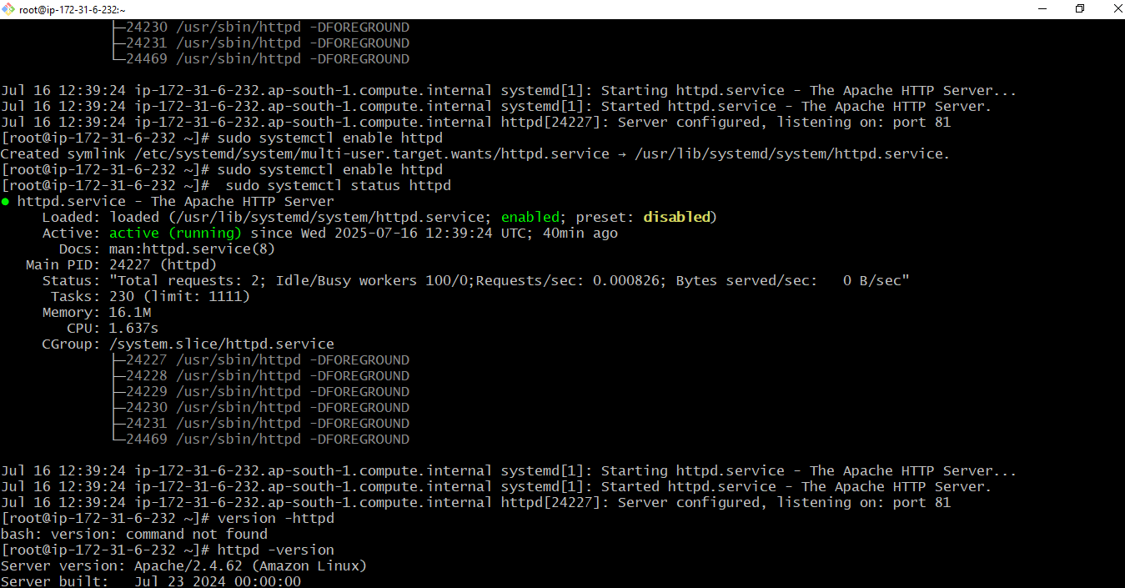

1. Install Nginx & Running with port 80

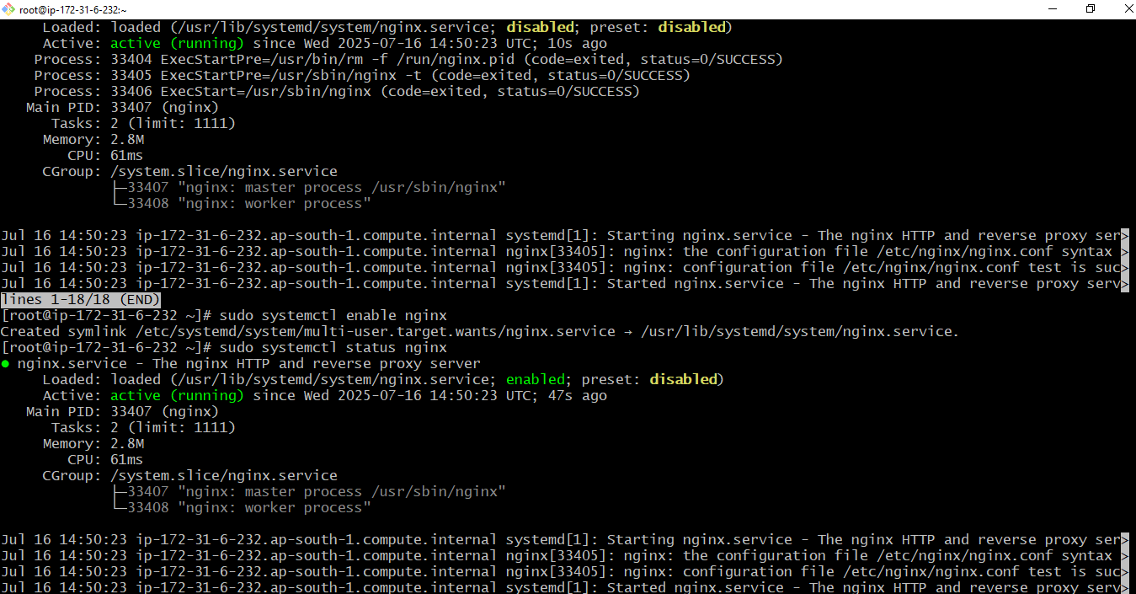

1. Install Apache Tomcat & Running on port 8082.

